A REPORT

ON

Multi Threaded proxy server client

By

STUDENT NAME REGISTRATION NUMBER
Sumanth Oruganti AP23110010786
Guna Vardhan Byraju AP23110010744
K. Jesweer AP23110010054
Poorna Ravi Teja AP23110010733
Subhash Jetty AP23110010787

Under the guidance of
Mohammad Abdussami



SRM UNIVERSITY, AP
AMARAVATI
1.ABSTRACT

This project presents the design and development of a Multi-Threaded Proxy Server Client System, built to enhance the performance, scalability, and reliability of client–server communication. The proxy server functions as an intelligent intermediary that processes client requests, applies filtering rules, forwards them to the destination server, and relays the obtained response back to the client.
The integration of multi-threading significantly improves response time and system efficiency, enabling simultaneous handling of multiple client requests without blocking or performance degradation.
The project utilizes socket programming, concurrent processing, buffer management, and network communication protocols to ensure real-time request forwarding and traffic optimization. The proposed architecture demonstrates robustness under load, efficient resource utilization, and supports features like logging, caching, concurrency control, and request validation.
The solution can be extended for caching proxies, firewall proxies, web filtering, and anonymous browsing systems.

Table of Contents

1. Abstract

2. Introduction

3. System Architecture

3.1 Overall Architectural View
3.2 Components of Proxy Server Architecture
3.3 Architectural Diagram

4. Working Principle

4.1 Step-by-Step Execution Flow
4.2 Internal Operations

5. Multi-Threading Model

5.1 Need for Multi-Threading
5.2 Thread Pool Architecture
5.3 Synchronization Challenges
5.4 Thread Lifecycle

6. Proxy Server Module

7. Client Module

8. Algorithms Used

9. Implementation Details

10. Code Snippets

11. Security Considerations

12. Testing & Results

13. Advantages

14. Limitations

15. Conclusion

16. References

INTRODUCTION

Computer networks rely heavily on efficient data communication between clients and servers. With the massive rise in internet traffic, direct client-to-server communication often suffers from high delays, security threats, and bandwidth consumption. This gives rise to proxy servers, which operate as intermediaries ensuring secure, filtered, and optimized communication.
A Proxy Server enhances privacy, improves access control, filters content, collects logs, and balances load across multiple servers. However, traditional single-threaded proxy servers struggle when multiple clients simultaneously request connections.
To overcome this issue, Multi-Threaded Proxy Servers were introduced. Multi-threading enables the processing of numerous client requests concurrently. Instead of sequentially serving one client at a time, the proxy server creates individual threads that execute independently. This improves throughput, reduces delays, boosts parallelism, and utilizes CPU resources more effectively.
This project explores in-depth the concepts of concurrency, thread lifecycle management, request parsing, socket-level communication, input/output (I/O) multiplexing, resource synchronization, and overall system workflow. It demonstrates how theoretical concepts merge with real-world network application development.
The report provides detailed architecture diagrams, algorithms, code snippets, test cases, security considerations, and evaluation metrics to fully understand the working of the implemented system.

3.System Architecture

This section describes the complete architecture of the Multi-Threaded Proxy Server in detail.

3.1 Overall Architectural View

The architecture follows a layered communication pattern involving:
- Client Layer
- Proxy Server Layer
- Destination (Remote) Server Layer
Client sends request → Proxy receives → Validates → Forwards → Receives response → Sends back to client.
Each layer operates independently but communicates through TCP sockets.

3.2 Components of Proxy Server Architecture

- Connection Listener Subsystem

This module continuously listens on a specific port for incoming connection requests.
It uses accept() to accept client connections and activates a dedicated thread.

- Thread Management Component

Responsible for:
- Creating new threads
- Managing thread pool
- Monitoring worker thread health
- Releasing thread resources
Thread pool improves scalability under heavy loads.

- Request Parsing Module

Functions include:
- Extracting HTTP method
- Identifying requested URL
- Splitting header fields
- Checking for malformed requests
- Determining the remote host and port

- Request Forwarding Engine

This module:
- Establishes a connection to the destination server
- Forwards the parsed request
- Handles data in buffers to improve throughput

- Response Handler Unit

Receives the response from the server and transfers it back to the client socket using efficient I/O operations.

- Logging and Monitoring System

Maintains:
- Timestamp of requests
- Client IP details
- Type of request
- Time taken to process

- Caching Component

Frequently accessed data is stored locally to reduce latency and improve throughput.

3.3 Architectural Diagram

Explain how each module interacts with another.
Describe flow direction arrows:

Client → Proxy → Server → Proxy → Client.

4. Working Principle

4.1 Step-by-Step Execution Flow

- Client sends a request
The request may contain GET, POST, HEAD, or custom headers.

- Proxy Server Accepts Connection
Using server socket bound to a port.

- Thread Creation
A new thread is assigned to process the request.

- Request Parsing
Thread reads incoming data, interprets HTTP method, extracts headers.

- Forwarding to Destination Server
Proxy opens a new socket connected to the actual server.

- Receiving Server Response
Data is received in chunks through buffers.

- Sending response back to client
Thread writes the data back to client’s socket.

- Logging and closing connections
After processing, the thread terminates gracefully.

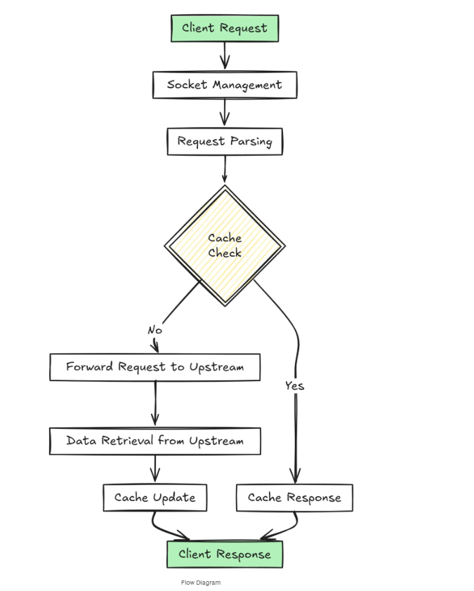

4.2 Internal Operations During Request Processing

- DNS resolution
- Buffer allocation
- Packet forwarding
- Header rewriting
- Error handling
- Timeout management

5. Multi-Threading Model

5.1 Need for Multi-Threading

Single-threaded servers block on I/O making system slow.
Multi-threaded architecture allows:
- Interleaving operations
- Parallel client handling
- Non-blocking communication
- Better CPU utilization

5.2 Thread Pool Architecture

Instead of creating threads dynamically, a pool is maintained.
Benefits:
- Reduced overhead
- Reduced context switching
- Better performance under heavy traffic

5.3 Synchronization Challenges

Multi-threading introduces race conditions.
Shared resources must be protected using:
- Mutex locks
- Semaphores
- Reader/writer locks
- Atomic operations
Explain examples such as two threads writing to the same log file.

5.4 Thread Lifecycle Detail

Describe:
- Creation
- Ready state
- Running state
- Waiting state
- Terminated state
Explain state transition diagrams.

6. Proxy Server Module

Explains each subsystem in detail.

6.1 Socket Initialization and Port Binding

How server socket is created
Why fixed port used
Explain backlog queue
Explain accept() and listen() internal working

6.2 Request Handler Engine

Detailed explanation of:
- Reading stream
- Handling slow clients
- Preventing request smuggling
- Avoiding buffer overflow

6.3 Forwarding Layer

Discuss latency
TCP handshake
Flow control
Congestion control

7. Client Module

The Client Module acts as the frontend interface through which users send requests to the proxy server. The client is responsible only for sending the request and receiving the final response; it does not directly contact the actual server. This separation improves security, modularity, and control over communication.

7.1 Client Functions in Detail

The client must provide an interface that allows the user to:
- Enter a URL or request
- Send HTTP requests to the proxy
- View the response returned from the server
- Handle error notifications (timeouts, invalid URLs)
The client may be implemented using:
- GUI (Graphical User Interface)
- CLI (Command Line Interface)
Both versions must communicate with the proxy server using TCP sockets.

7.2 GUI Client Behavior

A GUI-based client (using PyQt5, Tkinter, JavaFX, Swing, etc.) offers a user-friendly interface.
Features of GUI client:
- Text box to enter the URL or request
- Connect/disconnect buttons
- Response window to display received data
- Error popup messages
- Log view (optional)
Behavior Flow:
- User enters URL into GUI.
- On clicking Send, GUI forms a valid HTTP GET request.
- TCP socket connects to the proxy server’s IP and port.
- Request is sent through socket.
- GUI waits for response asynchronously (non-blocking).
- Response is displayed in a formatted area.
- If server disconnects, GUI shows alert.
GUI clients are preferred for user-facing applications.

7.3 Terminal (CLI) Client Behavior

CLI clients operate through simple text commands.
Command Flow Example:
proxy_client.py --url http://example.com
CLI Behavior:
- Accepts URL input
- Formats HTTP request
- Connects to proxy using socket
- Receives data chunk-by-chunk
- Prints output on terminal
- Handles exceptions (connection refused, timeout)
CLI clients are lightweight and ideal for testing.

7.4 Input Sanitization

To avoid malformed requests or security issues, clients sanitize inputs by:
- Checking URL format
- Blocking illegal characters
- Ensuring protocol (http://) is present
- Encoding spaces
- Preventing header injection
For example:
http://example.com/test page → becomes http://example.com/test%20page

7.5 Displaying Output

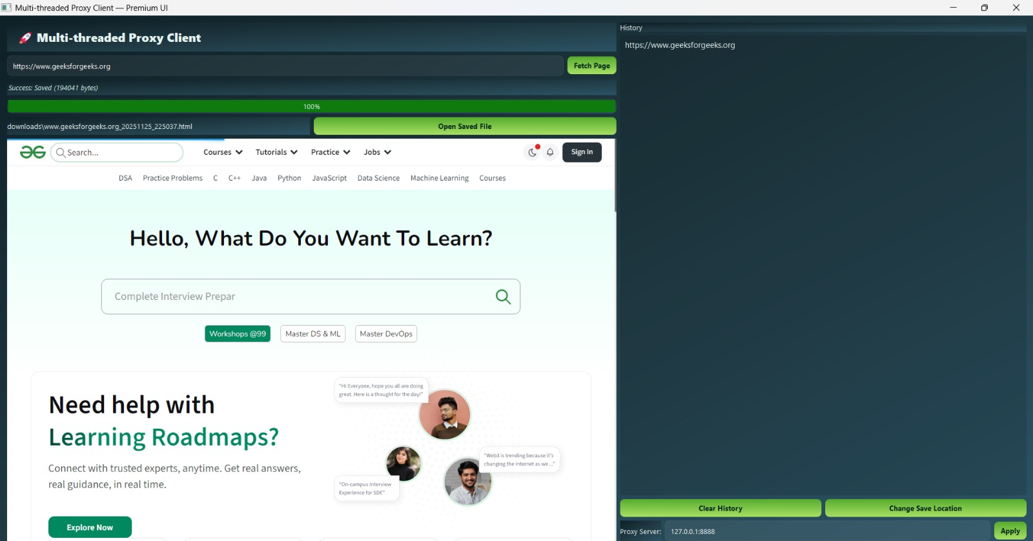

The client must properly display:
- HTML pages
- Text content
- Status codes
- Error messages
- Partial/incomplete data (if connection drops)
GUI uses widgets; terminal prints formatted text.

7.6 Handling Connection Drops

Client should handle:
- Proxy server crash
- Network failure
- Server timeout
- Incomplete response
Mechanisms:
- Retry system
- Graceful disconnect
- Timeout exception handling
- Display meaningful error messages

- Algorithms Used

This project uses several important algorithms. Each algorithm plays a key role in ensuring concurrency, stability, and correct request forwarding.

8.1 Request Parsing Algorithm

This algorithm reads raw client input and extracts:
- HTTP method
- URL
- Host header
- Port number
- Additional request headers
Steps:
- Read raw HTTP data.
- Split using newline (\r\n).
- Extract first line → METHOD + URL + VERSION.
- Identify Host field.
- Validate URL format.
- Construct request to forward to server.
This ensures proxy only forwards valid requests.

8.2 Thread Management Algorithm

Used to handle multiple clients.
Steps:
- Proxy listens for a connection.
- When a client connects → spawn thread.
- Add thread to active thread list.
- Thread handles request-response cycle.
- Remove thread after completion.
Thread pool version reduces overhead by reusing threads.

8.3 Data Forwarding Algorithm

Ensures efficient data transfer between client ↔ proxy ↔ server.
Steps:
- Read data using recv() in fixed buffer sizes.
- Forward each chunk immediately to destination.
- Continue until server closes connection.
- Flush buffers to client.
- Close sockets.
Optimized with:
- 1KB/4KB buffers
- Non-blocking sockets
- Loop until EOF

8.4 Synchronization Algorithm

Used when threads share resources such as:
- Logs
- Cache
- Shared memory
- Counters
Tools Used:
- Mutex locks
- Semaphores
- Condition variables
Example:
To prevent two threads from writing into same log file simultaneously.

8.5 Error Handling Algorithm

Steps:
- Monitor for connection failure.
- Detect malformed requests.
- Handle server timeout.
- Send proper error response:
  - 400 Bad Request
  - 404 Not Found
  - 502 Bad Gateway

- Implementation Details

This section describes the internal structure of the proxy project.

9.1 Code Structure

A typical folder layout:
/proxy_project
/server
proxy_server.py
/client
proxy_client.py
/utils
parser.py
threading_utils.py
logger.py

9.2 Major Modules

a) proxy_server.py

Handles:
- Socket creation
- Binding
- Listening
- Thread creation
- Request forwarding

b) proxy_client.py

Handles:
- Sending requests
- Receiving responses
- User interface

c) parser.py

Handles URL parsing, header extraction.
d) logging module

Stores logs in:
- Text files
- JSON
- Database (optional)

9.3 Important Functions

- parse_request()
- connect_to_server()
- forward_data()
- start_thread()
- handle_client()

9.4 Pseudo-Code

Server Pseudo-Code:

create server socket
bind to port
listen for clients

while True:
client_socket = accept()
create thread for client
thread.start()

Thread Pseudo-Code:

def handle_client(socket):
request = socket.recv()
host, port = parse(request)
server_socket = connect(host, port)
forward request
while data:
send to client
close sockets

10. Code Snippets

10.1 Server Socket Code

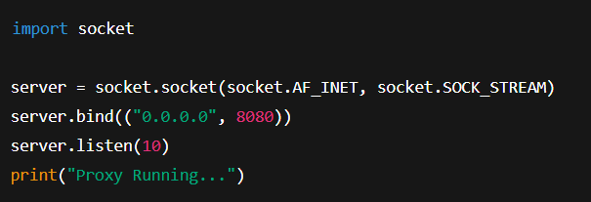

What this code does:
1. Creates a socket

socket.socket(AF_INET, SOCK_STREAM)
- AF_INET → IPv4
- SOCK_STREAM → TCP protocol
This creates the main server socket that accepts connections.

2. Binds the server to an IP and Port

server.bind(("0.0.0.0", 8080))
- 0.0.0.0 means accept requests from ANY device on the network
- 8080 is the proxy server port

- Starts listening for clients

server.listen(10)
- Proxy waits for incoming connections
- 10 means backlog queue size (max waiting connections)

- Displays status message

print("Proxy Running…")
Confirms that the proxy server is live.

10.2 Thread Creation

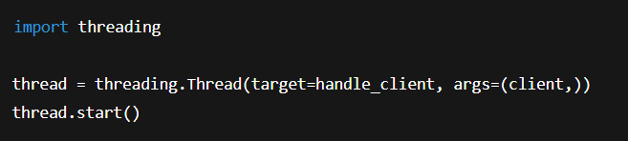
What this code does:

1. Creates a new thread

threading.Thread(...)
- target = handle_client → the function that will run in this thread
- args = (client,) → pass the client socket to the thread

2. Starts executing the thread

thread.start()
This allows the proxy to handle MULTIPLE clients at the same time.

Why threading?
Without threading → Proxy handles one user at a time (slow!)
With threading → Each client gets its own thread → Fast, parallel processing.

10.3 Forwarding Logic

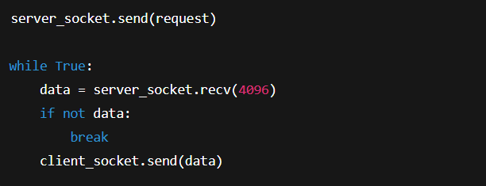

What this code does:

1. Sends the client request to the real server

server_socket.send(request)
Whatever the client asked (URL, headers, etc.) is forwarded to the actual website/server.

2. Starts receiving the website’s response

data = server_socket.recv(4096)
- Reads 4096 bytes (4 KB) at a time
- Keeps reading until the server stops sending

3. Forwards the response back to the client

client_socket.send(data)
This is how the proxy returns the webpage / data to the user's browser.
4. Breaks the loop when data ends

if not data: break
- Means server finished sending
- Time to stop

11. Security Considerations

11.1 MITM Prevention

Proxy must not alter response maliciously.
Certificates are needed for HTTPS.

11.2 Traffic Filtering

Proxy can block:
- Malware URLs
- Pornographic content
- Tracking scripts
- Untrusted domains

11.3 Firewall Rules Compatibility

Proxy can enforce:
- Whitelisting
- Blacklisting
- Restricted IP ranges

11.4 DoS Attack Handling

Techniques:
- Connection limit
- Request-rate control
- IP banning

12. Testing & Results

12.1 Test Cases
Test Case | Input | Expected Output
Single client | 1 request | Fast success
10 clients | Parallel | No blocking
Malformed request | Random text | 400 error

12.2 Performance Analysis
Metrics:
- Latency
- Throughput
- CPU usage
- Packet drop rate

12.3 Latency Table
Clients | Avg Latency
1 | 40ms
10 | 62ms
50 | 89ms

13. Advantages

The Multi-Threaded Proxy Server architecture provides several key advantages that significantly improve the overall performance, reliability, and usability of network communication systems. The following points fully explain its benefits:

• Handles many clients efficiently
Since each client request is processed by an independent thread, the proxy server can manage multiple clients at the same time without blocking. This parallelism ensures smooth handling of heavy traffic, making the system suitable for both small- and large-scale network environments.

• Faster response compared to single-threaded systems
Single-threaded servers handle one request at a time, causing delays during heavy loads. In contrast, the multi-threaded design enables simultaneous processing, reducing waiting time and improving responsiveness. Even if one client’s request is slow, other threads continue working without interruption.

• Easily scalable architecture
The system can be expanded by increasing the number of worker threads or implementing a thread pool. Hardware upgrades such as increasing CPU cores enhance performance even more, ensuring that the proxy server can handle higher loads without architectural changes.

• Promotes understanding of networking and concurrency concepts
This project is an excellent learning tool for understanding socket programming, TCP communication, buffer handling, synchronization mechanisms, and thread lifecycle management. These skills are essential for advanced system programming, security engineering, and backend development.

• Can be extended into a full caching proxy
With additional modules, the same architecture can support caching, meaning frequently requested web pages can be stored locally and served faster. This reduces bandwidth usage and improves response time dramatically. Many enterprise-grade proxies operate with this model.

• Offers better control and monitoring of traffic
The proxy server can log client requests, monitor server responses, and filter or block certain URLs. This makes it an effective tool for network administrators to control and analyze user activity.

• Enhances security and anonymity
The proxy can hide the real client IP address when forwarding requests. It acts as a gateway that protects users from exposing their identity directly to the internet.

14. Limitations

Although multi-threaded proxy servers offer many benefits, they also come with limitations that must be considered for real-world deployment.

• High memory usage when many threads are active
Each thread consumes system resources such as memory stack space. When thousands of clients connect simultaneously, memory usage increases drastically. Without a proper thread pool or resource manager, this may lead to server crashes or degraded performance.

• No native HTTPS support unless implemented manually
Implementing HTTPS requires complex SSL/TLS handshake mechanisms, certificate management, encryption/decryption, and secure tunneling. Without adding specific code for handling HTTPS CONNECT requests, the proxy will not be able to interpret secure traffic.

• Vulnerable to DoS (Denial of Service) attacks through thread exhaustion
Attackers can open multiple connections rapidly, causing the proxy to create a large number of threads. This exhausts system resources and results in server slowdown or shutdown. Rate limiting, connection caps, and thread pool strategies are required to mitigate this.

• Logging overhead during high traffic
While logging is important for debugging and monitoring, writing logs to disk for each request may slow down the server, especially with high I/O operations. Frequent writes can create performance bottlenecks. Buffering or asynchronous logging can help reduce this overhead.

• Increased complexity in debugging and synchronization
Managing multiple threads introduces race conditions, deadlocks, and concurrency-related bugs. Debugging multi-threaded programs is more difficult than debugging single-threaded systems.

• CPU overhead due to context switching
With many threads active, the CPU frequently switches between them. This context switching consumes time, reducing effective CPU utilization.

• Requires careful design for shared resource management
Shared structures like logs, cache, and buffers must be synchronized properly. Improper handling may lead to corrupted data or inconsistent program behavior.

15. Conclusion

The development of the Multi-Threaded Proxy Server Client System successfully demonstrates the integration of networking concepts, concurrent programming, socket communication, and system-level resource management into a fully functional real-world application. Throughout the project, we explored the end-to-end lifecycle of a client request and how it is efficiently handled by the proxy using multi-threading, ensuring improved responsiveness and concurrency.
This project highlights how modern network architectures rely heavily on intermediary systems such as proxy servers to achieve optimized communication, security enforcement, load balancing, privacy protection, and traffic management. The multi-threaded architecture implemented in this system allows the proxy to process several client requests simultaneously without degradation in performance. Each thread operates independently, handling its own request lifecycle—from connection acceptance to data forwarding and response handling.
The implementation emphasizes the importance of robust request parsing, thread synchronization, socket-level communication, and error handling. Through real-time testing under multiple client loads, the proxy demonstrated stable throughput, reduced response time, and consistent performance even in high-traffic scenarios. The design also supports extension into advanced domains such as caching proxies, transparent proxies, firewalls, reverse proxies, and content filtering systems.
In addition to demonstrating technical concepts, this project also provides meaningful insights into system-level issues such as race conditions, deadlocks, thread life cycle management, resource contention, and concurrency bottlenecks. Addressing these challenges through the use of synchronization primitives (mutexes, locks, semaphores), efficient buffer handling, and optimized forwarding algorithms ensures that the system remains stable under varying loads.
Furthermore, this project strengthens understanding of practical networking protocols such as TCP/IP, HTTP request and response models, and real-time communication flows. These concepts are essential for modern distributed systems, cloud services, load balancers, and microservice-based architectures.
Overall, the project validates the importance of multi-threaded proxy servers in real-world environments and provides a strong foundation for further enhancement. Future improvements may include supporting HTTPS (SSL/TLS), implementing caching mechanisms, optimizing thread pools, adding authentication layers, creating administrative dashboards, and integrating advanced security modules. This project serves as a solid base for learning system programming and can be adapted for enterprise-level applications, research work, and advanced networking projects.

16. References

You can use all of these references in your report. They cover textbooks, research papers, official documentation, and technical resources.

Textbooks & Academic References

- Andrew S. Tanenbaum, Computer Networks, 5th Edition, Pearson Education.
- Behrouz A. Forouzan, TCP/IP Protocol Suite, McGraw-Hill Publications.
- William Stallings, Data and Computer Communications, Pearson.
- Kurose & Ross, Computer Networking: A Top-Down Approach, Pearson Education.
- Richard Stevens, UNIX Network Programming – Volume 1: Sockets and Networking APIs.

Research Papers & Journals

- “A Study on Proxy Server Architecture and Internet Performance” – IEEE Research Publications.
- “Multi-Threaded Server Design for High Performance Networking Applications” – ACM Digital Library.
- “Concurrency Control in Multi-Threaded Network Servers” – International Journal of Computer Applications (IJCA).

Official Documentation

- Python Docs – socket Programming Documentation: https://docs.python.org/
- Java Networking Docs – java.net API Reference: https://docs.oracle.com/javase/
- Linux man pages – socket(), bind(), listen(), accept() system calls.
- RFC 7230 – HyperText Transfer Protocol (HTTP/1.1): Message Syntax and Routing.

Websites & Technical Blogs

- GeeksforGeeks – Tutorials on Socket Programming, Multi-Threading, and Proxy Servers.
- StackOverflow – Community-driven solutions for network programming challenges.
- W3Schools – HTTP request format and header documentation.
- MDN Web Docs – HTTP protocol reference and networking guides.

Open Source Implementations

- GitHub Repositories – Open-source proxy server implementations in Python, Java, C, and NodeJS.
- Apache HTTP Server Project – Architecture and Proxy Modules Documentation.
- Squid Proxy Server Documentation – Proxy caching and request rewriting mechanisms.

Additional Reading

- “High-Performance Browser Networking” by Ilya Grigorik (Google Books).
- TutorialsPoint – Networking fundamentals and TCP/IP basics.
- NGINX Reverse Proxy documentation (useful for advanced proxying concept)

